DON’T MISS THE
ARIZONA FULBRIGHT ASSOCIATION SPRING BARBECUE!

DATE: FRIDAY, MARCH 15
TIME: 4 PM
PLACE: HIMMEL PARK , Tucson (Look for us on the Southwest side of the park)

Himmel Park is on Tucson Boulevard, about 1 mile east of the University of Arizona ; one block south of Speedway and one block north of 3rd Street. Parking is on the north side of the park, just east of the tennis courts and just west of Himmel Library.

The Chapter will supply meat, chicken, fruit, cookies, non-alcoholic beverages, and condiments. Feel free to bring a dish to share. There is a playground for children, nearby restrooms, and it is a lovely setting!

Questions? Contact Kirk Simmons (simmonsk@arizona.edu) or Carol Bender (bender@arizona.edu)

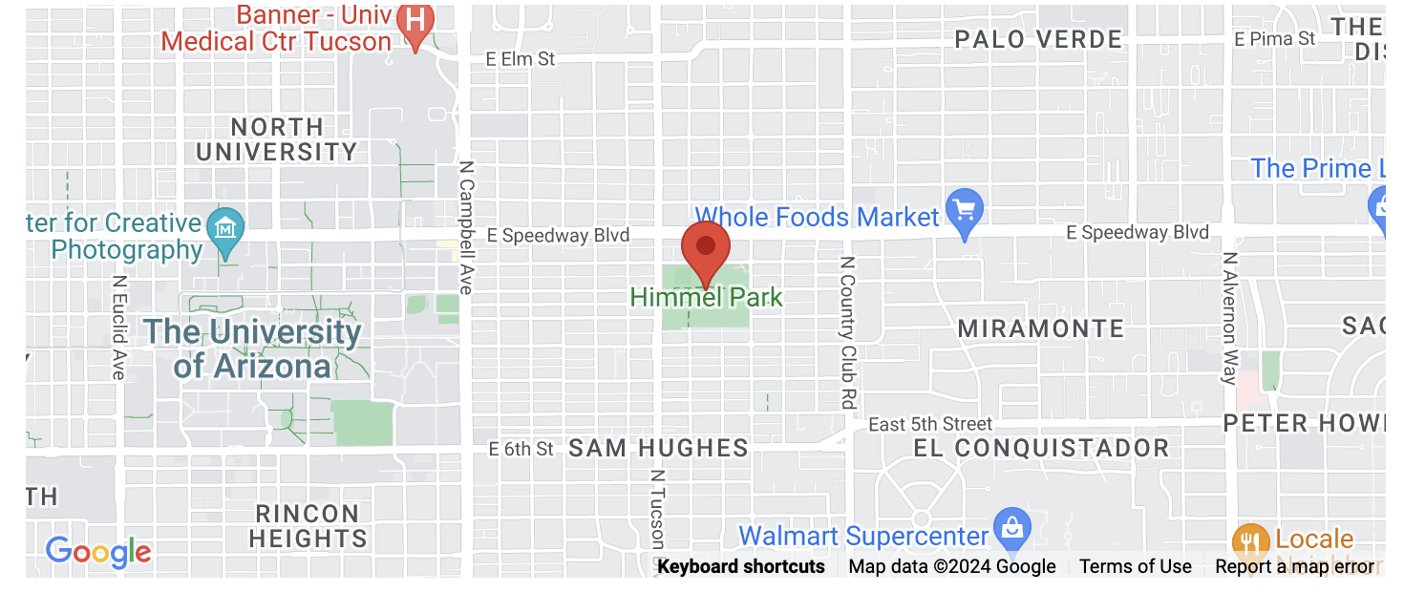
See you there!!!

